SUBCOURSE EDITION
IT 0344 A

US ARMY INTELLIGENCE CENTER

BASIC LAWS OF
BOOLEAN ALGEBRA
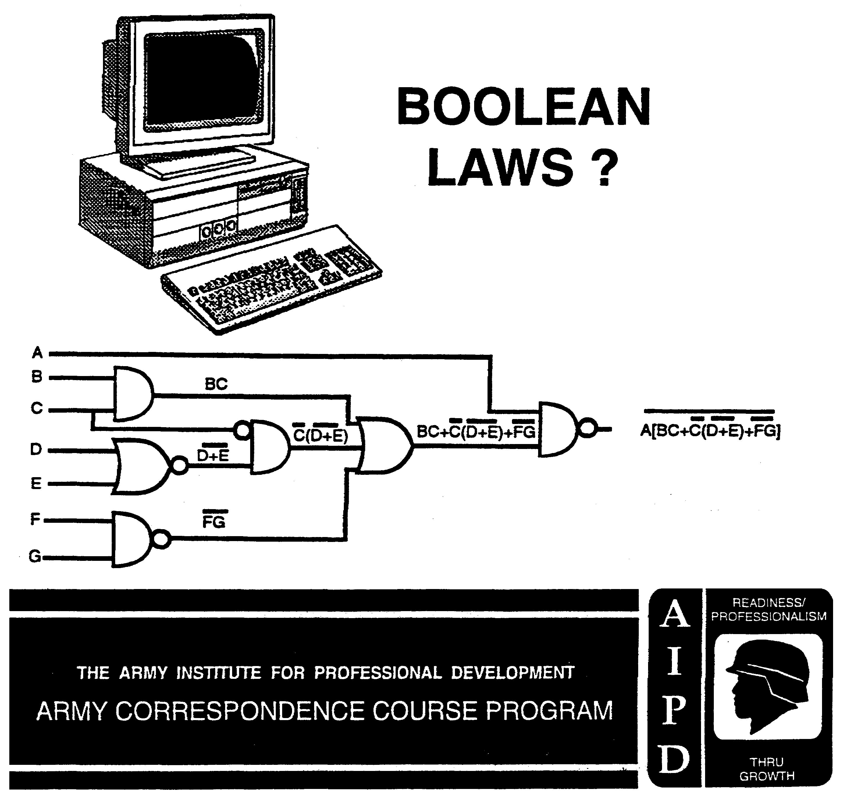

BASIC LAWS OF BOOLEAN ALGEBRA

Subcourse Number IT 0344

EDITION A

US ARMY INTELLIGENCE CENTER
Fort Huachuca, AZ 85613-6000

5 Credit Hours

Edition Date: JULY 1997

SUBCOURSE OVERVIEW

This subcourse is designed to teach you the application of the basic laws of Boolean Algebra to the simplification of electronic circuits.

Prerequisites for this subcourse are Subcourses IT 0342 and IT 0343.

This subcourse replaces SA 0714.

ACTION: You will be able to simplify algebraic expressions of electronic circuits by applying the basic laws and identities of Boolean Algebra.

CONDITION: Given algebraic expressions of electronic circuits and a summary of the basic laws and identities.

STANDARD: To demonstrate competency of this task, you must achieve a minimum of 70% on the Subcourse Examination.

i IT 0344

TABLE OF CONTENTS

Section Page

Subcourse Overview i

Lesson: Basic Laws of Boolean Algebra 1-1

Practical Exercise 1-33

APPENDIX-BASIC LAWS

IT 0344 ii

LESSON

BASIC LAWS OF BOOLEAN ALGEBRA

OVERVIEW

LESSON DESCRIPTION:

In this lesson you will learn to apply the basic laws of Boolean Algebra to the simplification of electronic circuits.

TERMINAL LEARNING OBJECTIVE:

ACTION: Simplify algebraic expressions of electronic circuits by applying the basic laws and identities of Boolean Algebra.

CONDITION: Given algebraic expressions of electronic circuits and a summary of the basic laws and identities.

STANDARD: To demonstrate competency of this task, you must achieve a minimum of 70% on the subcourse examination.

SUBCOURSE ORGANIZATION. The pages of this subcourse are divided into two sections, the Frames and responses/answers. The frames are the largest area of the page and they are numbered sections. The responses/answers are not numbered and are on the left side of each page. The correct response/answer to a frame is in the following response/answer block. Periodically, there are additional instructions in the response/answer block referring you to other areas in the subcourse that contain step by step solutions.

1-1 IT 0344

 | 1. Boolean Algebra aids the computer technician in understanding
 | electronic computer circuits. The basic laws of Boolean Algebra are
 | used to manipulate and simplify Boolean expressions. The simplest
 | electronic circuits which will accomplish a particular function are
 | designed by applying the basic laws to manipulate and simplify Boolean
 | expressions. Keep in mind, however, that the laws of Boolean Algebra
 | do not correspond exactly to the laws of ordinary Algebra.
 | Boolean Algebra is used to ______________________________ and
 | _______________________ Boolean expressions.
manipulate | 2. Boolean Algebra utilizes the binary numbering system. In the binary
simplify | numbering system, there are only two possible constants, '1 and 0, and
 | only two possible values for any variable, also 1 and 0. A Boolean
 | expression can be multiplied by following the same rules used in
 | ordinary Algebra; however, since the largest value in the binary
 | numbering system is 1, no squares are generated. For example, in
 | ordinary Algebra, the expressions (A+B)(A+B) multiplied together are
 | expressed as A²+AB+BA+B². In Boolean Algebra, the same
 | expressions (A+B)(A+B), multiplied together are expressed as
 | AA+AB+BA+BB. In Boolean Algebra, A multiplied by A (A•A) is
 | indicated as AA; B multiplied by B (B•B) is indicated as BB, etc.

IT 0344 1-2

 | 2. (Continued)
 | Multiply the Boolean expressions below, using Boolean Algebra.
 | a. (A+D)(A+C) c. (A+B)(AB+C)
 | b. (AB+C)(R+S) d. (A)(A+B)
a. AA+AC+DA | 3. Boolean Algebra is used to
+DC
 | a. convert Boolean expressions to binary O's and 1's.
b. ABR+ABS+CR
+CS | b. communicate with digital computers in binary.
c. AAB+AC+BAB | c. manipulate and simplify Boolean expressions.
+BC
 | d. simplify Boolean expressions involving complex Algebra.
d. AA+AB
c. | 4. Multiply the following Boolean expressions:
 | a. (J+R)(RT) c. P(T+P+PT)
 | b. (LM)(M+L+T) d. (A+N)(N+C)

1-3 IT 0344

a. JRT+RRT | 5. Boolean Algebra is a method of mathematically representing logical
b. LMM+LML | operations. In order to represent logical operations, a set of basic
+LMT
 | laws and identities has been developed for Boolean Algebra. It is not
c. PT+PP+PPT
 | as important to know these laws and identities by name as it is to
d. AN+AC+NN
+NC | know when and how to put them to use. One of the basic laws of
 | Boolean Algebra is the law of IDENTITY, which states: “Any letter,
 | number, or expression is equal to itself." For example, A = A; B = B
 | C = C; RJ = RJ; etc. The switching-circuit diagram and the truth
 | table of the law of IDENTITY are shown below.
 | 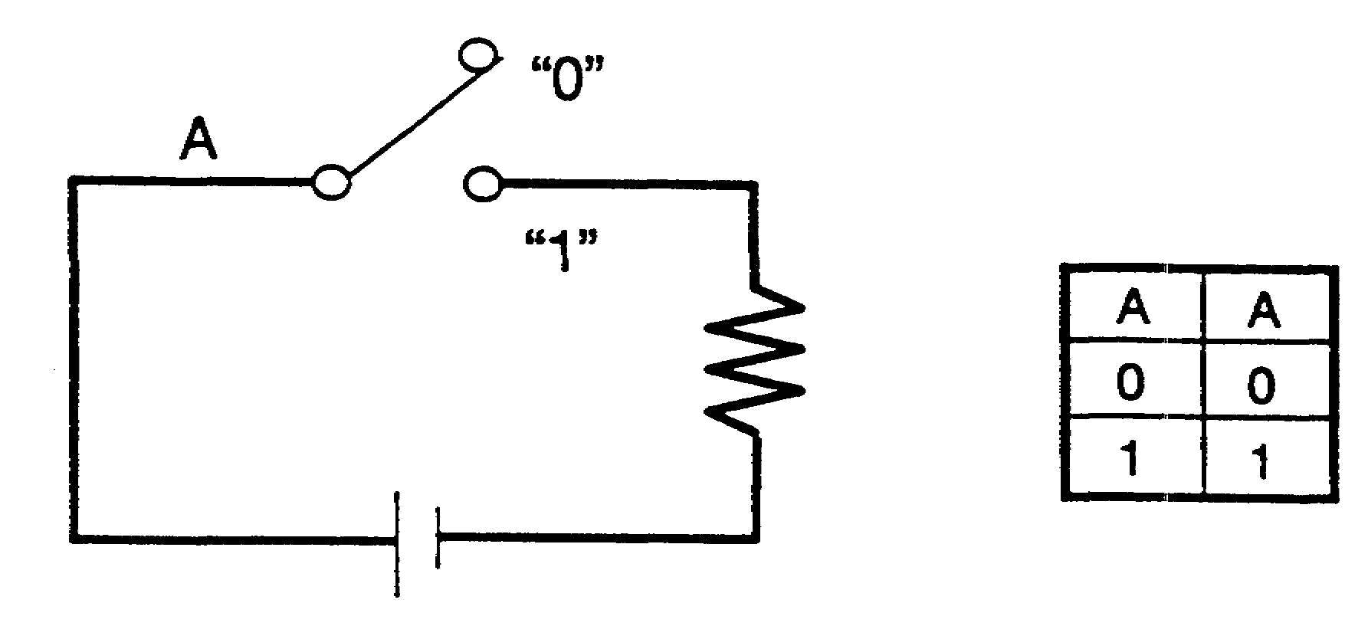
 | LAW OF IDENTITY
 | Select examples of the law of IDENTITY from the following.
 | a. 1 = 1 e. A = B
 | b. A = B f. O = O
 | c. A = 1 g. A = A
 | d. B = B h. AB = AB

IT 0344 1-4

a. | 6. Another basic law of Boolean Algebra is the COMMUTATIVE law,
d. | which states: “When inputs to a logic diagram are ANDed or ORed,
f. | the order In which the output Boolean expression is written does not
h. | affect the binary value of the output." For example, AB = BA; A+B =
 | B+A; PDQ = QPD; C+J+S = J+C+S; etc. The logic diagrams and
 | truth tables below show that the output Boolean expression of an
 | AND circuit or an OR circuit can be written without regard to the
 | order of the factors.
 | 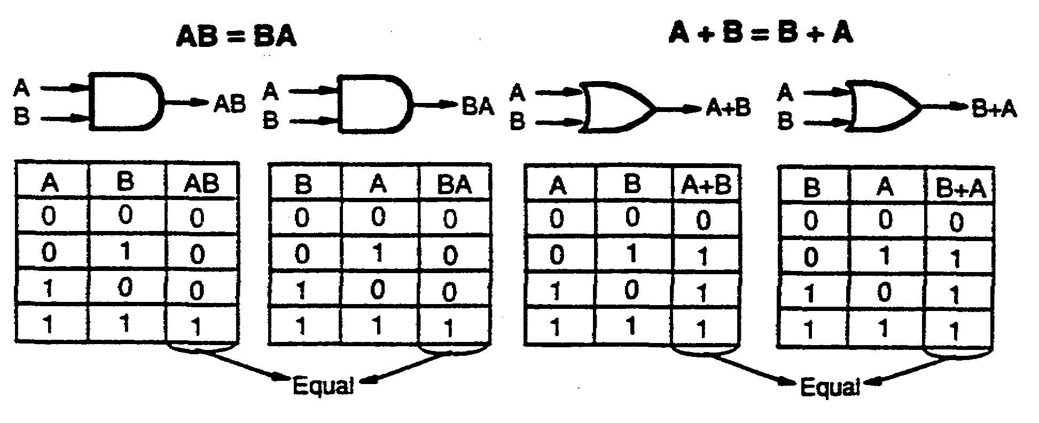
 | COMMUTATIVE LAW
 | Indicate two ways the output Boolean expressions can be
 | written for each of the following.
 | a. b.
 | 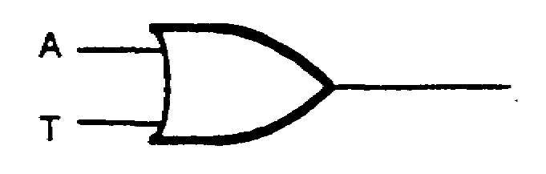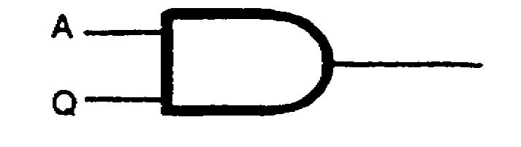

1-5 IT 0344

a. A+T | 7. In the logic diagram below, the output may be written ACD. List two
T+A
 | additional ways the output can also be correctly written.
b. AQ
QA | 
ADC | 8. When applying the COMMUTATIVE law, observe signs of grouping
CAD | and apply the law to only the logic diagram under consideration.
CDA  DAC  DCA | 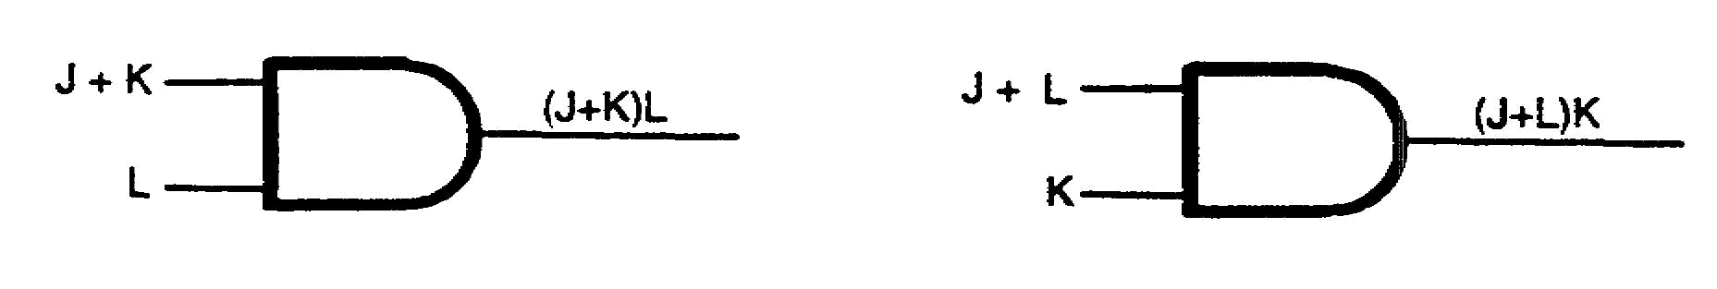
(Any two.) | As illustrated above, the Boolean expressions (J+K) L and (J+L) K for
 | the logic diagrams contain the same variables, but the expressions
 | are not equal.
 | According to the COMMUTATIVE law, is (M+N) S equal to (M+S) N?
No. | 9. Select examples of the law of IDENTITY.
 | a. XYZ = XYZ d. ABCD = ABD
 | b. KLT = KLT e. MN= MN
 | c. TUB = TUB f. AT=TD

IT 0344 1-6

b. | 10. Using the COMMUTATIVE law, select the expressions below which
c. | are equal.
e. | a. K (L+M) and (M+L) K
 | b. W+X+YZ and ZY+X+W
 | c. A(BC+D+E) and (E+BC+D) A
 | d. GH+J and HI+G
 | e. (D+F) E and E(F+D)
b. | 11. To aid in simplifying Boolean expressions, learn to recognize terms
c. | within the expressions which are equal. For example:
e. | BCC + ADE + DEA
 | EQUAL
 | Circle the terms which are equal in each expression below.
 | a. AB +AC + BA
 | b. CE+A+EC+CE
 | c. EB+AG+BE+AG

1-7 IT 0344

a. AB, BA | 12. Two possible combinations of inputs to logic diagrams are shown
b. EC, C E | below.
c. EB, B E | a.
 | 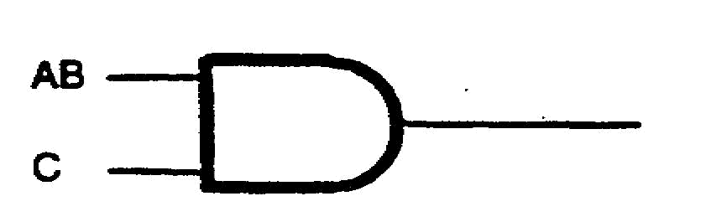
 | ANDed INPUT TO AND SYMBOL
 | b.
 | 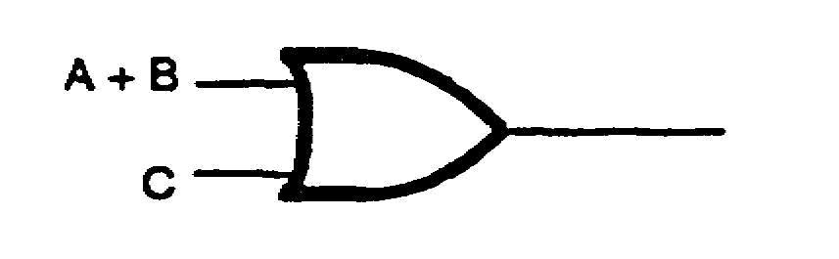
 | ORed INPUT TO OR SYMBOL
 | Write the output Boolean expression for the diagrams above.
 | a.
 | b.
a. (AB) C | 13. The output Boolean expressions of the logic diagrams above contain
b. (A+B) +C | parentheses to indicate grouping. It is possible to remove the
 | parentheses from the output Boolean expressions, which will result in
 | simplified diagrams. To remove the parentheses, the ASSOCIATIVE
 | law is used. The ASSOCIATIVE law is illustrated on the following
 | page with the corresponding logic diagrams and truth tables.

IT 0344 1-8

13. (Continued)
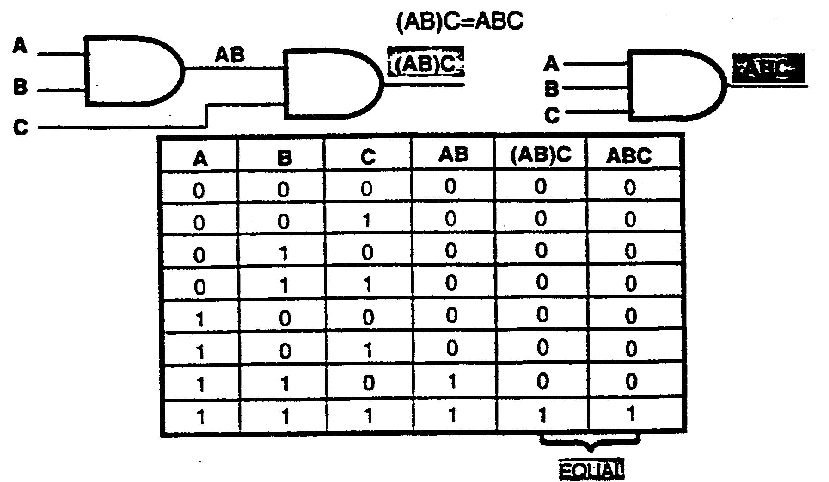
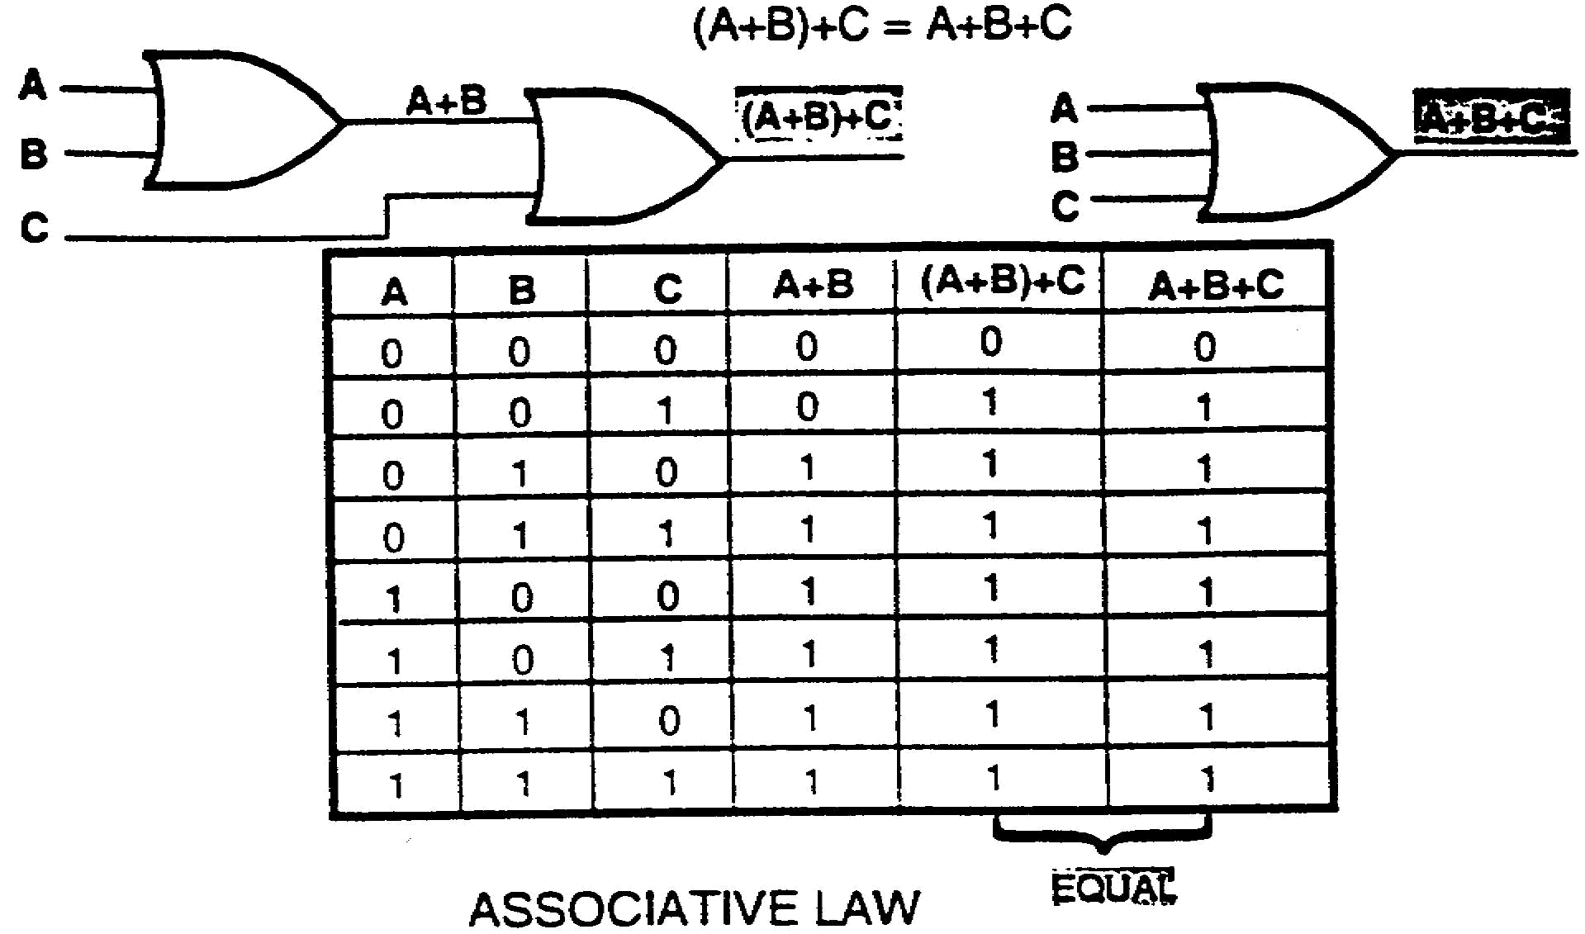
The logic diagrams and truth tables above prove that the parentheses
can be removed and a simplified diagram obtained when there is an
ANDed input to an AND gate or an ORed input to an OR gate.
Simplify the following Boolean expressions, using the ASSOCIATIVE
law.
a. R (ST) c. (A+B+C) +D
b. L+ (M+R) d. R (US) T

1-9 IT 0344

a. RST | 14. A simplified expression, which resulted in a simplified logic diagram,
b. L+M+R | was obtained in frame 13 by using the ASSOCIATIVE law. The
c. A+B+C+D | simplified logic diagram enables a circuit to be constructed which will
d. RUST | be more economical, while still performing the desired function.
 | Which logic diagram below will result in the simplest, most economical
 | circuit?
 | a. b.
 | 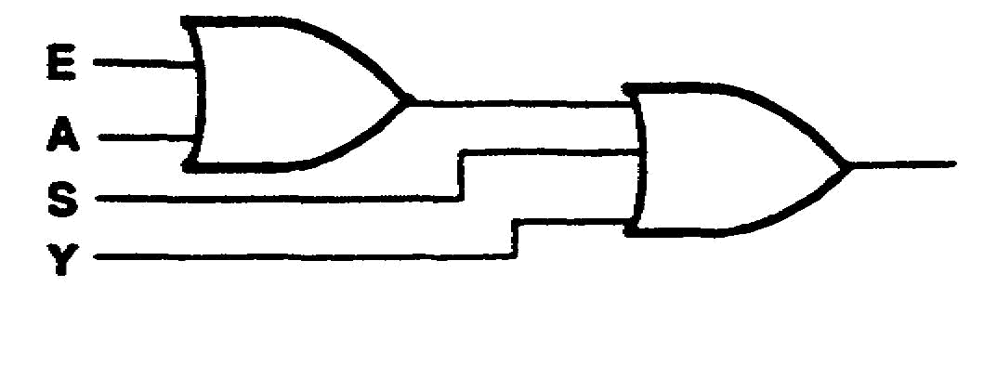
b. | 15. Using the ASSOCIATIVE law, simplify the following Boolean
 | expressions:
 | a. AB (CDE)
 | b. C+(D+E) + (F+G)
 | c. (UV)(WX)(YZ)
 | d. (T+UV) +t (W+ XYZ)

IT 0344 1-10

a. ABCDE | 16.
b. C+D+E+F+G  c. UVWXYZ  d. T+UV+W+XYZ | 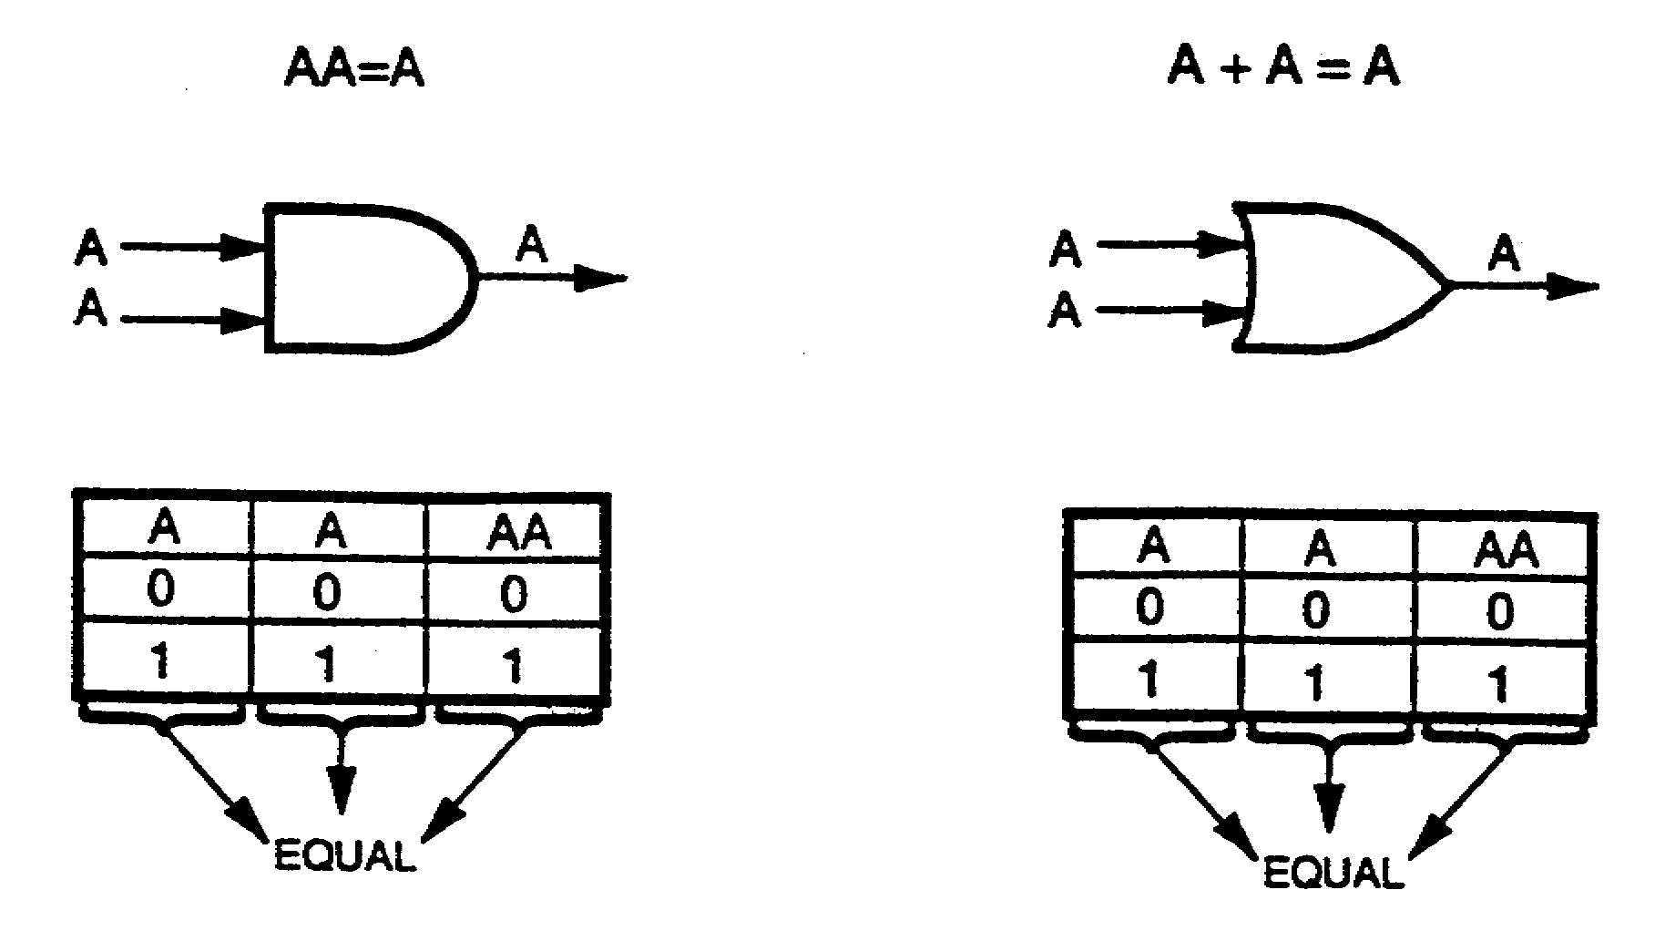
 | IDEMPOTENT LAW
 | The IDEMPOTENT law is illustrated above with the corresponding
 | truth tables. If input A is ANDed with input A or if input A is ORed with
 | input A, the output will have a binary value of A.
 | Complete the truth tables for the logic diagrams below.
 | a.
 | 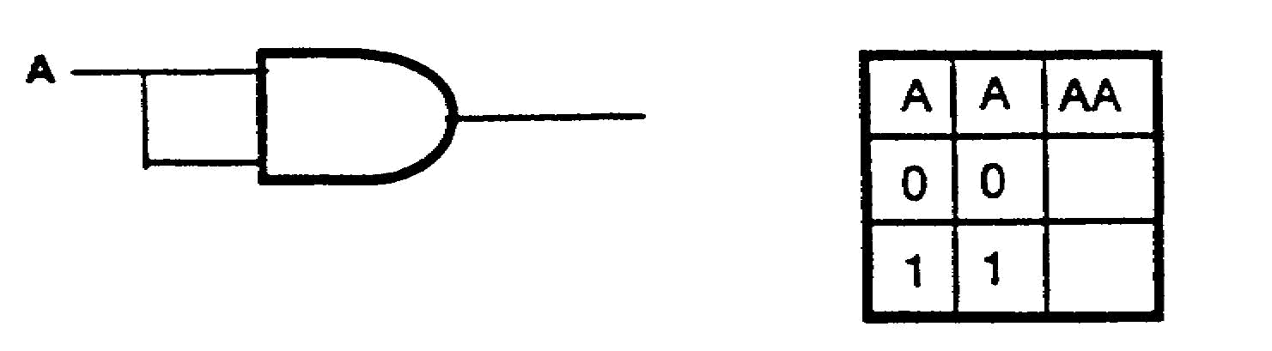
 | b.
 | 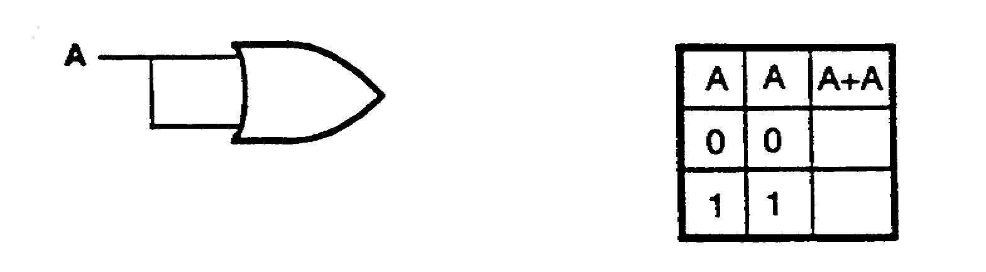

1-11 IT 0344

a. | 17. Using the IDEMPOTENT law, simplify the following Boolean
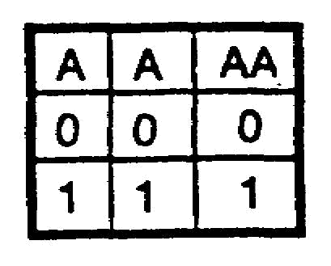 | expressions:  a. P+P
 | b. A+B+A+C+B+D
b.
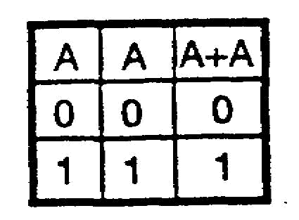 | c. (RS)(RS)  d. XY Z+XY Z
a. P | 18. The laws which have been covered up to this point are listed below.
b. A+B+C+D | IDENTITY: A=A A=A
c. RS | COMMUTATIVE: AB = BA A+B = B+A
d. XY Z | ASSOCIATIVE: A (BC) = ABC A+ (B+C) = A+B+C
 | IDEMPOTENT: AA = A A+A = A
 | These are a few of the laws which are used to simplify Boolean
 | expressions. For example:
 | (XY) + (YX) + (AB) + (BA) + (EE)
 | COMMUTATIVE
 | (XY) + (XY) + (AB) + (AB) + (EE)
 | IDEMPOTENT
 | (XY) + (AB) + (E)
 | ASSOCIATIVE
 | XY+AB+E
 | Simplify the following Boolean expressions by using the required laws.
 | a. (LL)(MM)

IT 0344 1-12

 | 18. (Continued)
 | b. FG+(FG+H)
 | c. SR+(RT+RS)
 | d. (ST+Z)(AR)(RA)(Z+TS)
a. LM | 19.
b. FG+H  c. SR+RT  d. (ST+Z)(AR) | 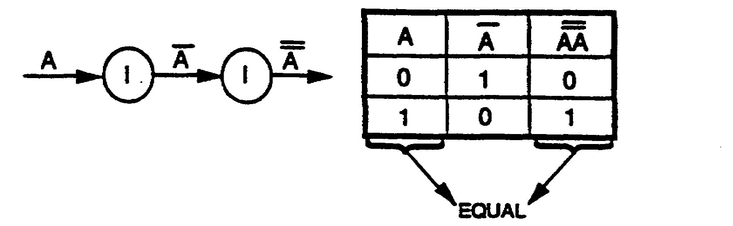
Step by step  solutions on | LAW OF DOUBLE NEGATION: A = A
page A-2.
 | The diagram and truth table above represent the law of DOUBLE
 | NEGATION. Whenever two vincula of equal length extend over the
 | same variable or expression, both vincula may be removed by using
 | the DOUBLE NEGATIVE law. For example, A = A; CD = CD; A+B =
 | A+B; etc.
 | Simplify the following Boolean expressions, using the DOUBLE
 | NEGATIVE law.
 | a. X Y Z c. (R+S) T
 | b. AB+X d. L M T

1-13 IT 0344

a. XYZ | 20. When more than two vincula of equal length extend over the same
b. AB+X | variable, term, or expression, the vincula may be removed two at one
c. (R+S) T | time by using the DOUBLE NEGATIVE law. For example, A = A; CD
d. LMT | = CD; X+Y = X+Y; etc.
 | By using the DOUBLE NEGATIVE law, ____________
 | vincula may be removed at the same time.
two | 21. Simplify the following Boolean expressions, using the DOUBLE
 | NEGATIVE law.
 | a. AB + C
 | b. B + F + GH
 | c. (R + S) T + Z
 | d. AB + BD
a. AB+C | 22. Simplify the following expressions, using the laws that have been
b. B+F+GH | covered.
c. (R+S) T+Z | a. C + DG + FD + G + C
d. AB+BD | b. (Q +R + S) +S + (R + Q)
 | c. (MNP + Q) L + K
 | d. (WXY + Z) (Z + WXY)

IT 0344 1-14

a. C+DG+FD+G . | 23. When any variable or Boolean expression is ANDed with its
b. Q + R + S | complement, the output is 0. When any variable or Boolean
c. (MNP+Q) L+K | expression is ORed with its complement, the output is 1. This is
d. WXY +Z | called the law of COMPLEMENTS, as shown by the logic diagrams
 | and corresponding truth tables below.
Step by steps  solutions on  page A-2. | 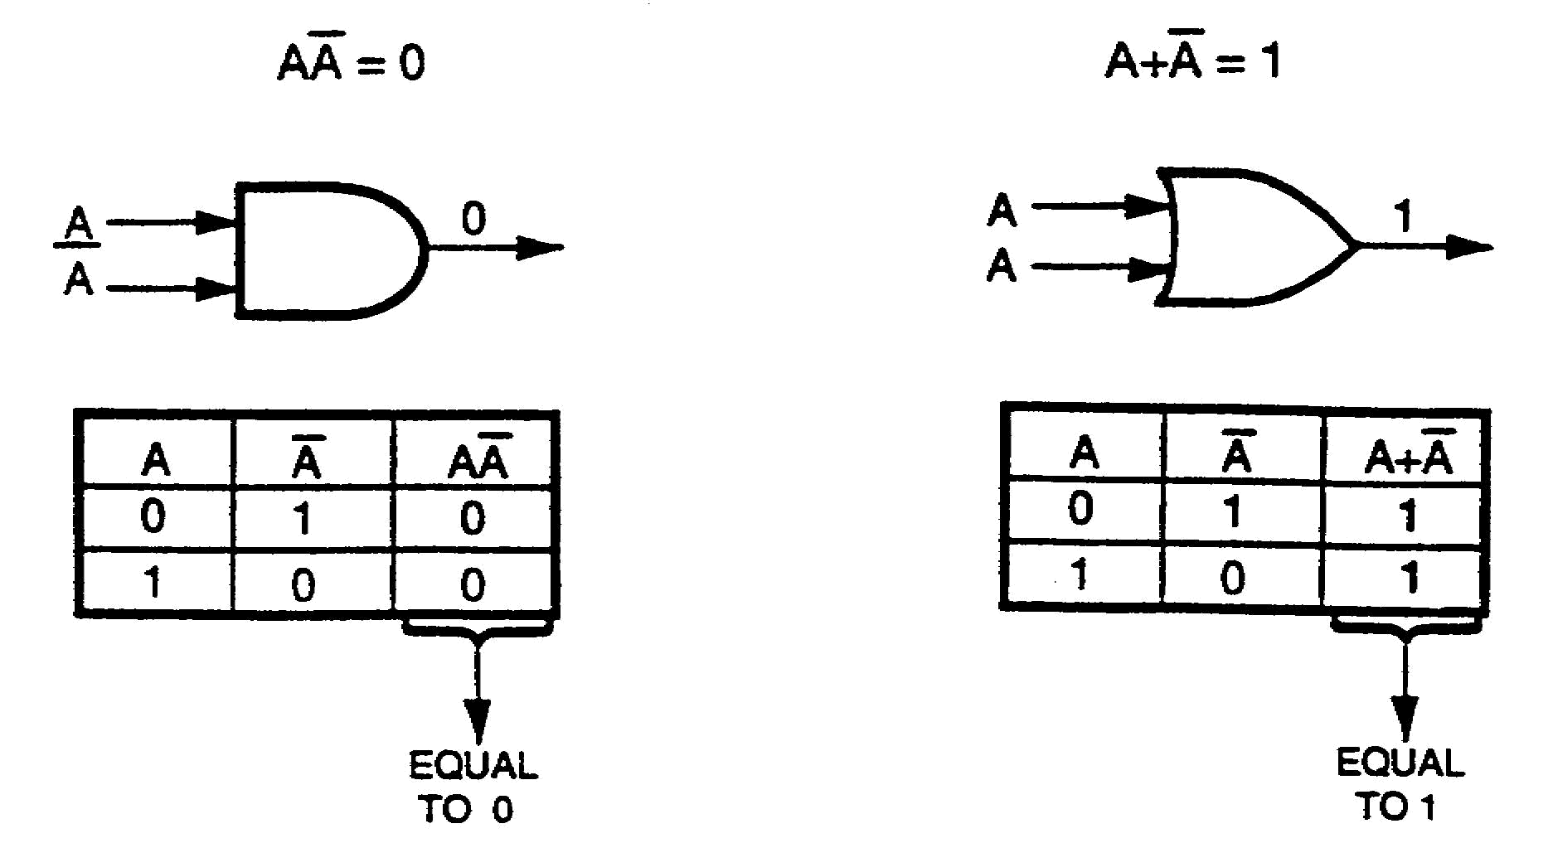
 | LAW OF COMPLEMENTS
 | Examples of the LAW OF COMPLEMENTS are: AA = 0; JRC + JRC
 | = 1, T+ T = 1; (DR + H)(DR + H) = 0; etc.
 | Write the outputs for the logic diagrams below.
 | a. b.
 | 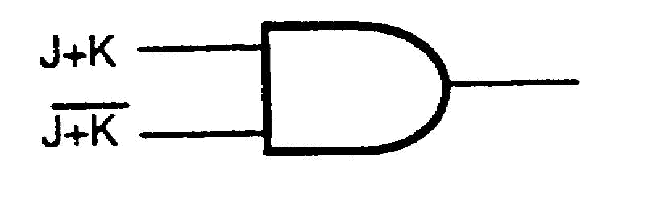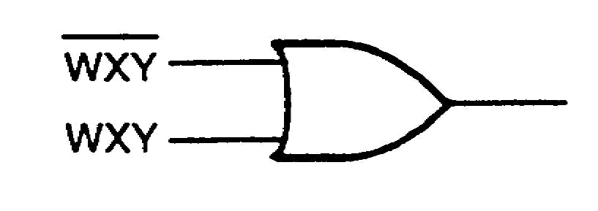
a. 0 | 24. Whenever any variable or Boolean expression is ANDed with its
b. 1 | complement, the output is ________.

1-15 IT 0344

0 | 25. Whenever any variable or Boolean expression is ORed with its
 | complement, the output is _________.
1 | 26. Using the law of COMPLEMENTS, state the output for each of the
 | following expressions or logic diagrams:
 | a. FLR + FLR
 | b. JKJK
 | c. G+G
 | d.
 | 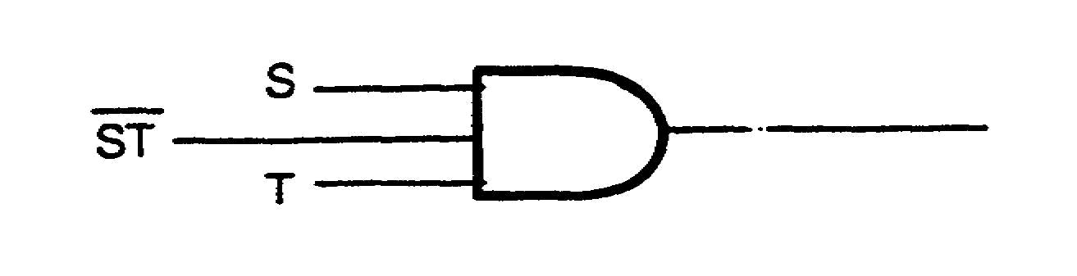
 | e.
 | 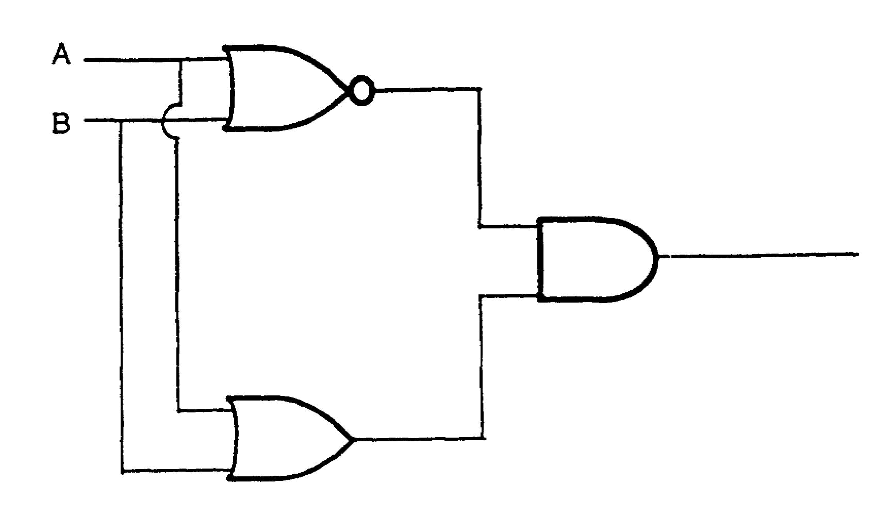

IT 0344 1-16

a. 1 | 27. Another aid in simplifying Boolean expressions is the law of
b. 0 | INTERSECTION: A(0) = 0 and A (1) = A, illustrated below.
c. 1  d. 0  e. 0 | 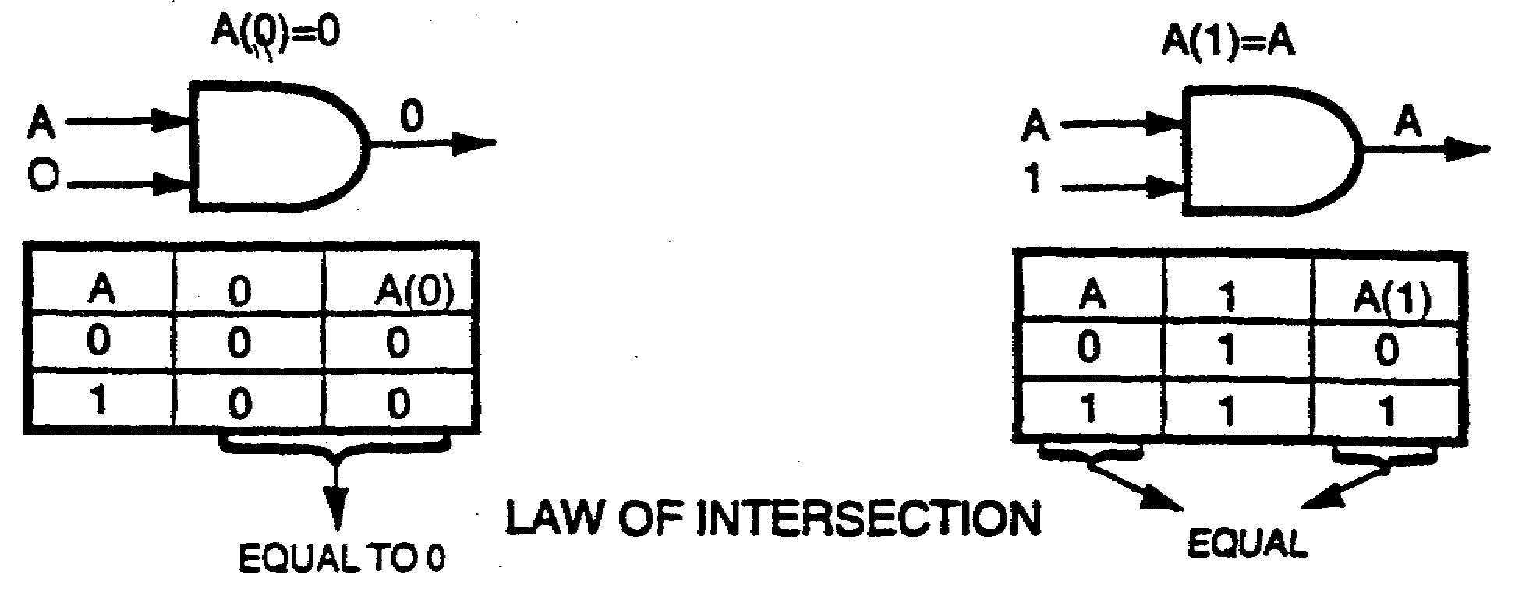
 | Complete the following truth tables for the law of INTERSECTION.
 | a. b.
 | 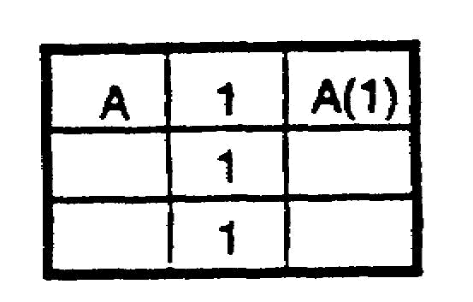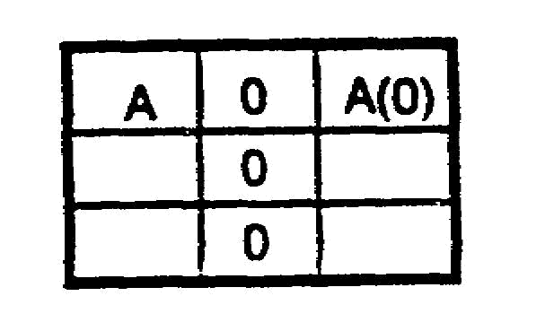
a. | 28.
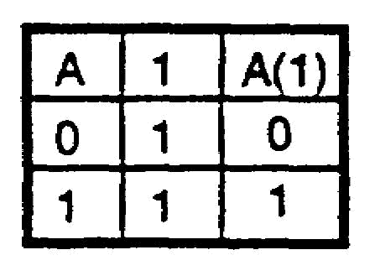 | 
b. | In the logic diagram above, when input A is at the 1 level, the output
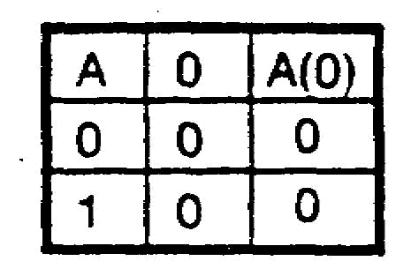 | is _______; when input A is at the 0 level, the output is _______.
1  0 | 29.  
 | In the logic diagram above, when input A is at the 1 level, the output
 | is _______; when input A is at the 0 level, the output is _______.

1-17 IT 0344

0 | 30. The substitution method may be applied as an aid in understanding
0
 | the basic laws of Boolean Algebra. For example, the law of
 | INTERSECTION, A(0) =0, could readily be applied to simplify the
 | following Boolean expression:
 | TPZ (0) = 0
 | Substitute A for the term TPZ, and the expression becomes A(0) =.
 | From page 17 it is found that A(0) =0, according to the law of
 | INTERSECTION; therefore, TPZ(0) = 0.
 | Using the law of INTERSECTION below, simplify the following
 | Boolean expressions:
 | A(1) =A A(0) =0
 | a. B(1) = ? c. (BC+C) 0 = ?
 | b. 0 (D+F+RS) = ? d. (Y+Z) 1 = ?
a. B | 31. The law of UNION is similar to the law of intersection, with the
b. 0 | exception that the law of UNION applies only to OR logic, as shown
c. 0 | below.
d. (Y+Z) | 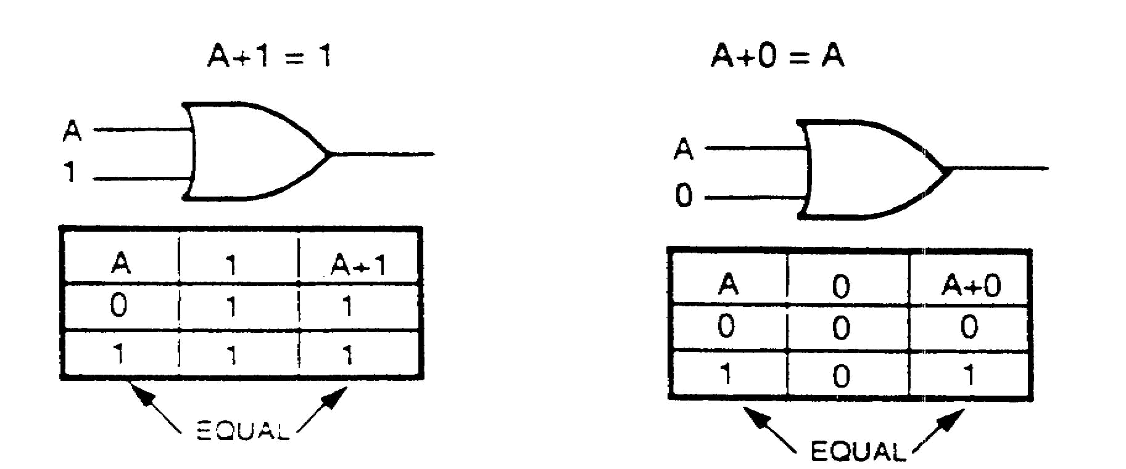
 | LAW OF UNION

IT 0344 1-18

 | 31. (Continued)
 | Complete the following truth tables for the law of UNION.
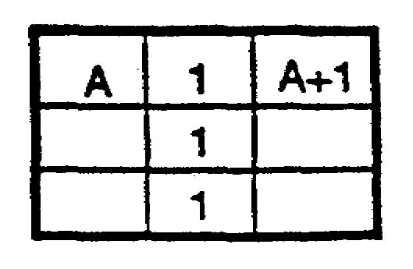
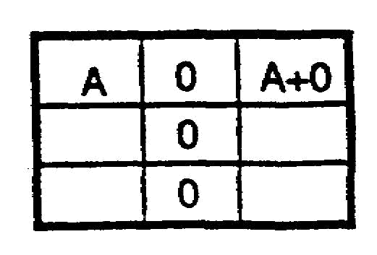
 | a. b.
a. | 32.
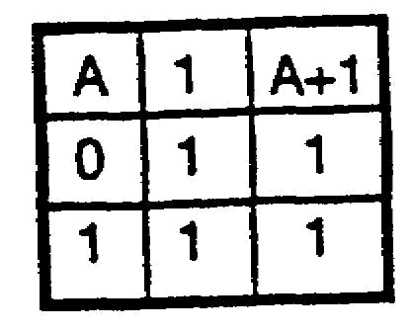 | 
b. | In the logic diagram above, when input A is at the 1 level, the output
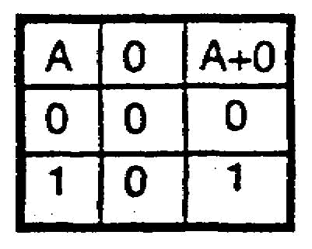 | is ______; when input A is at the 0 level, the output is _______.
1 | 33.
 | 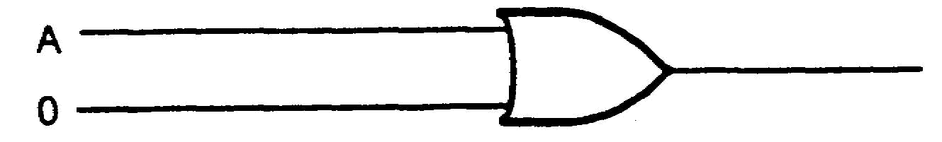
1 | In the logic diagram above, when input A is at the 1 level, the output
 | is _______; when input A is at the 0 level, the output is _______.
1 | 34. A+1=1 A + 0 =A
0 | Using the law of UNION above, simplify the following Boolean
 | expressions:
 | a. 0+C=? b. 1 +ABE=?
 | c. QC+0=? d. LM+NP+1 =?
 | NOTE: The substitution method used in frame 30 may be applied
 | as an aid in simplifying b, c, and d above. Use substitution
 | whenever necessary in the remainder of this program.

1-19 IT 0344

a. C | 35. The laws which have been covered, up to this point, are
b. 1 | IDENTITY: A=A A = A
c. QC | COMMUTATIVE: AB = BA A+B=B+A
d. 1 | ASSOCIATIVE: A(BC) = ABC A+(B + C) = A + B + C
 | IDEMPOTENT: AA = A A + A = A
 | DOUBLE NEGATIVE A=A
 | COMPLEMENTARY: AA = 0 A + A = 1
 | INTERSECTION: A • 1 =A A • 0=0
 | UNION: A+1=1 A+0=A
 | 36. Simplify the following Boolean expressions, using the basic laws of
 | Boolean Algebra.
 | a. T+(V-0) +0
 | b. E + 0 (AF)
 | c. 0(K+LM+0)
 | d. DF+(G+G)

IT 0344 1-20

a. T | 37. DE MORGAN'S THEOREM is used to split a vinculum which extends
 | over more than one variable or to join separated vincula into one
b. E | extended vinculum. DE MORGAN'S THEOREM is illustrated below
 | with the logic diagrams and corresponding truth tables.
c. 0
d. 1  Step by step  solutions on  page A-3. | 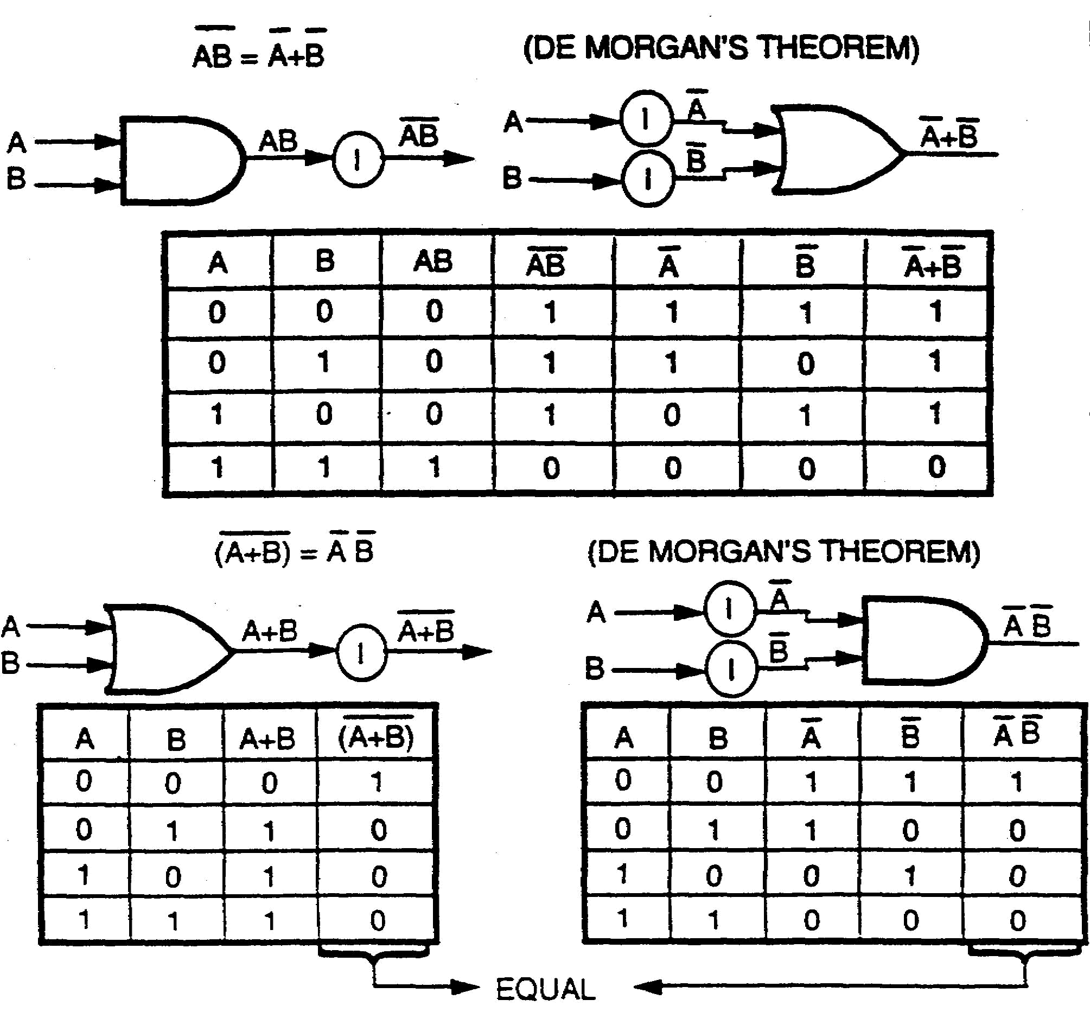
 | DE MORGAN'S THEOREM
 | Whenever vincula are split or joined, change the sign (AND to OR or
 | OR to AND) as indicated below.
 | 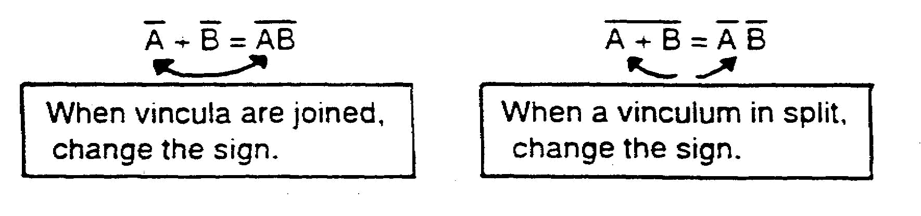

1-21 IT 0344

 | 37. (Continued)
 | Split or join the vincula in the Boolean expressions below, using DE
 | MORGAN'S THEOREM.
 | a. J+K+L b. R+S+T+Y
 | c. DEFG d. WRY
a. J K L | 38. When the signs are changed in a Boolean expression, group the
b. RSTY | same variables that were originally grouped. For example:
c. D+E+F+G | AB + C = (A + B) C
d. W+R+Y | Same grouping
 | Split or join the vincula in the Boolean expressions below, using DE
 | MORGAN'S THEOREM.
 | a. H+SL b. (T+V) W
 | c. R + LM d. (S+T)(R+P)
a. H (S+L) | 39. If any variable in a Boolean expression has more than one vinculum
b. TV+W | over it, the expression is not in the simplest form. For example, B +
c. R (L+M) | CD is not in the simplest form, because variable B has two vincula
d. ST + RP | over it. To simplify Boolean expression B + CD, the longest vinculum
 | is split first by using DE MORGAN'S THEOREM, as follows:
 | B +CD =BCD = B (C+D)
 | The expression is simplified further by using the DOUBLE
 | NEGATIVE law, as follows:

IT 0344 1-22

 | 39. (Continued)
 | B (C+D) = B (C+D)
 | Simplify the Boolean expressions below, using DE MORGAN'S
 | THEOREM, the DOUBLE NEGATIVE law, and the ASSOCIATIVE
 | law.
 | a. (J + K)(L + M) b. (R + S)(D + E)
 | c. DE+(R + S) d. X+Y+FG
a. J K+L+M | 40. Often, Boolean expressions cannot be simplified until the
b. R+S+D E | expressions have been converted to another form. The
c. DER S | DISTRIBUTIVE law is used to convert Boolean expressions from
d. X Y FG | one form to another. The DISTRIBUTIVE law is illustrated on the
Step by step | following page with the logic diagrams and corresponding truth
solutions on
page A-3. | tables.

1-23 IT 0344

40. (Continued)
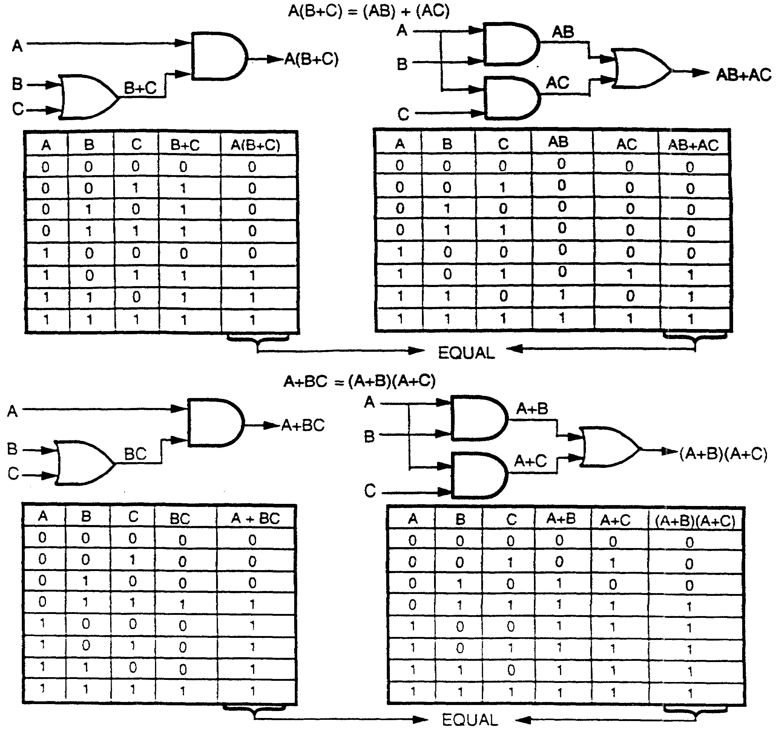
DISTRIBUTIVE LAW
To obtain a 1 output from the Boolean expression A(B+C), input A must be at the 1 level, as
well as either input B or input C. In the Boolean expression A(B+C), there are two
combinations of variables which will produce a 1 output: AB or AC. Therefore, A(B+C) =
AB+AC. When an expression takes the form of A(B+C) or AB+AC, it can be converted to
the opposite form by using the DISTRIBUTIVE law.
A(B+C) = AB+AC AB+AC = A(B+C)

IT 0344 1-24

40. (Continued)
Convert the following Boolean expressions, using the
DISTRIBUTIVE law.
a. D(E+F+G) b. QR+QS+QT
c. V(W+Y+Z) d. JK+JKL+JKM

1-25 IT 0344

a. DE+DF+DG | 41. Another form of the DISTRIBUTIVE law is as shown by the lower
b. Q (R+S+T) | set of logic diagrams and truth tables in (frame 40). When input A is
c. VW+VY+VZ | at the 0 level, the truth table indicates that both input B and input C
d. JK (1 +L+M) | must be at the 1 level to obtain a 1 output from the Boolean
 | expression (A+B)(A+C). Therefore, (A+B)(A+C) may be expressed
 | as A + BC. This can be proved by applying the basic laws of
 | Boolean Algebra as follows:
 | (A + B)(A + C)
 | BA + AB + AC=BC CARRYING OUT MULTIPLICATION
 | A + AB + AC + BC IDEMPOTENT
 | A(1 + B + C) + BC DISTRIBUTIVE
 | A = 1 + BC UNION
 | A + BC INTERSECTION
 | *When the DISTRIBUTIVE law is used, removing a variable by itself
 | will leave a 1, as shown below.
 | A + AB = (A + AB) = A(1 + B)
 | Convert the following Boolean expressions, using the DISTRIBUTIVE
 | law A + BC = (A + B)(A + C)
 | a. K + LM b. (R + S)(R + T)
 | c. TV + X d. J + KLM

IT 0344 1-26

a. (K + L)(K + M) | 42. Convert the Boolean expressions below, using the DISTRIBUTIVE
b. R + ST | law.
c. (T + X)(V + X) | a. W + ZXY b. RS + STV + PSX
d. (J + K)(J + L) | c. DE(F + G + H) d. X + RHS
(J + M)
a. (W + Z)(W + X) | 43. There are two equations pertaining to the law of ABSORPTION:
(W + Y)
 | A(A + B) =A and A+(AB) =A. How a single variable effectively absorbs
b. S(R + TV + PX)
 | other variables may appear confusing; however, the explanation
c. DEF + DEG + DEH
 | below, which uses logic diagrams and truth tables, will prove that the
d. (X + R)(X + H)
(X + S) | equations are, in fact, valid. Since the law of ABSORPTION is often
 | used in simplifying Boolean expressions, carefully study the
 | following:
 | 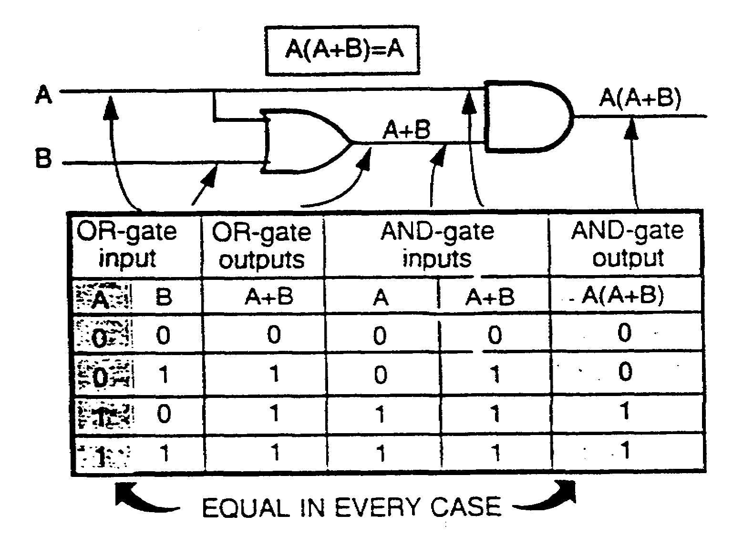
 | The A input column of the truth table above and the A(A + B) output
 | column are equal (identical) in every case; therefore, A(A + B) is
 | equal to A. In other words, the A variable has effectively absorbed

1-27 IT 0344

43. (Continued)
the (A + B) portion of the equation, with the result that A(A + B) = A.
Any Boolean expression in the form of A(A + B) can be simplified by
using the law of ABSORPTION. Any variable (or quantity) ANDed
with an ORed output which contains that variable (or quantity) will
absorb the ORed output. (Refer to the logic diagram on the
preceding page.) For example, the Boolean expression
(T + H + I + S) S can be simplified to a single S variable, because the
ORed output (T + H + I + S) contains the same S variable and is
effectively absorbed. Boolean expression AC(AC + ZECA + X YACP)
is simplified to AC, because all the terms within the ORed portion
of the expression contain the AC variables and are effectively
absorbed, leaving the simplified expression AC. Simplify the
following Boolean expressions, using the law of ABSORPTION.
a. A(A + W) = b. AM(MA + THAM) =
c. (SW + WAST) WS = d. (HR + ZXRH) HR =

IT 0344 1-28

a. A | 44. The equation A+(AB) =A, pertaining to the law of ABSORPTION, is
b. AM | shown below with the corresponding logic diagram and truth table.
c. WS  d. HR | 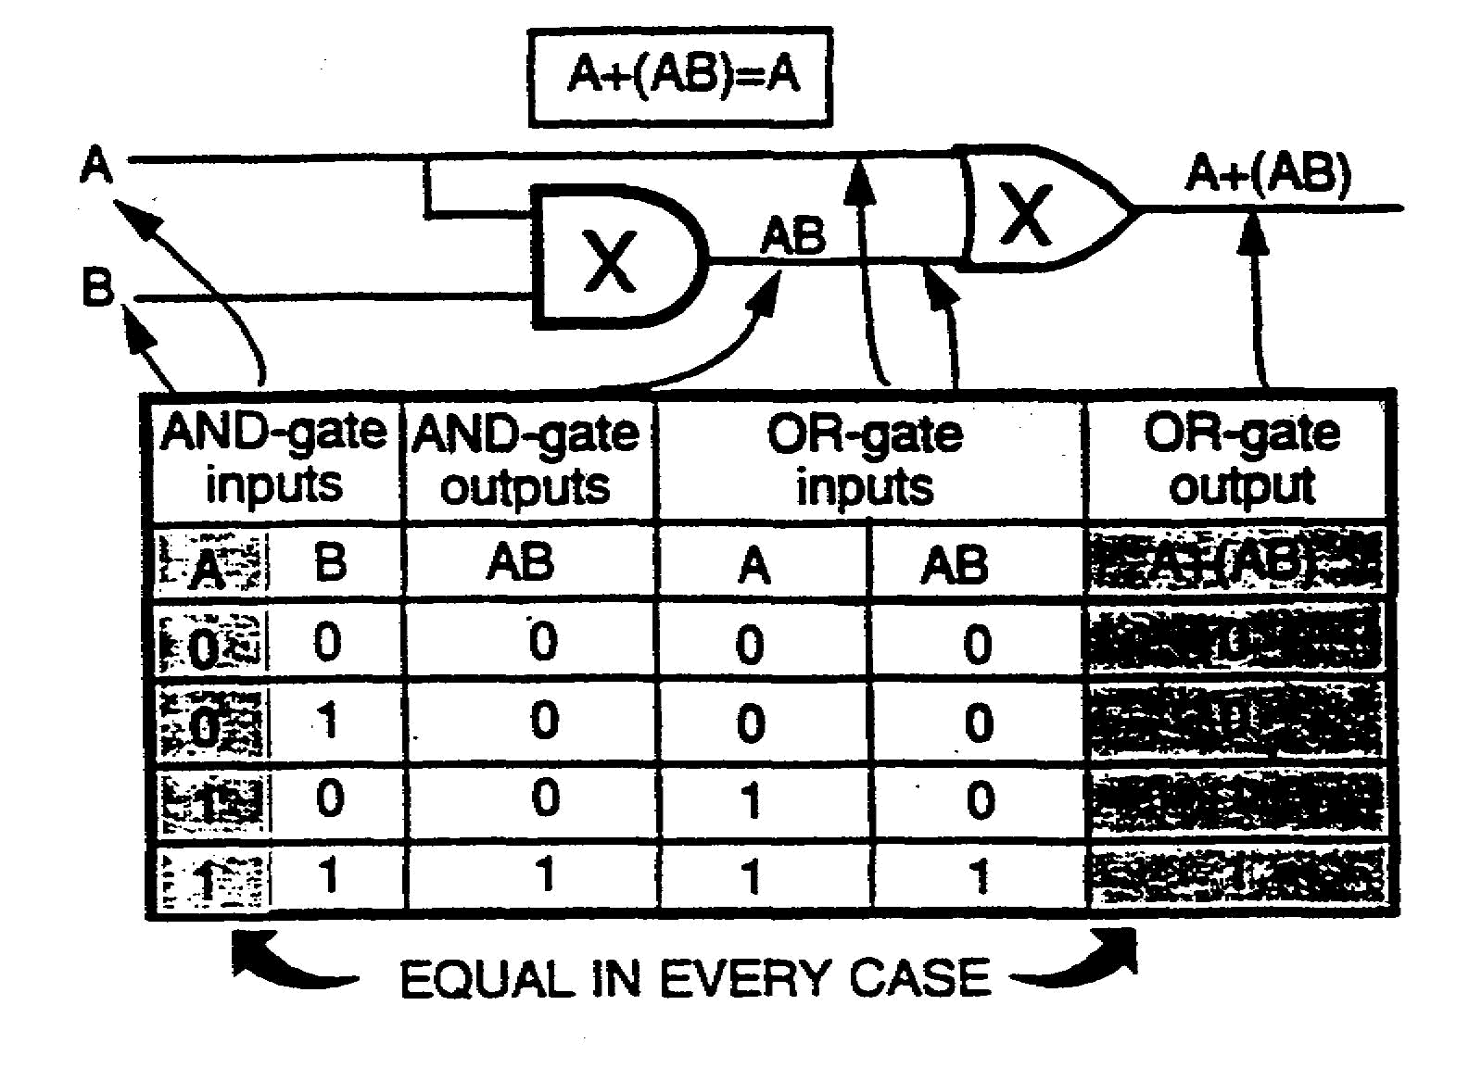
 | As shown by the truth table above, the AND-gate input A and the
 | OR-gate output A+(AB) are equal (identical) in every case.
 | Therefore, A+(AB) is equal to A. Any Boolean expression in the
 | form of A+ (AB) can be simplified by using the law of
 | ABSORPTION. Any variable or quantity ORed with an ANDed
 | output which contains that variable or quantity will absorb the
 | ANDed output. (Refer to the logic diagram above.) For example,
 | the Boolean expression C+(XDC) can be simplified to a single C
 | variable, because the ANDed output (XDC) contains the same C
 | variable and is effectively absorbed.

1-29 IT 0344

44. (Continued)
Boolean expression KM+(ABKM+CDMK+F EKM) is simplified to
KM, because all the terms within the ANDed portions of the
expression contain the KM variables and are effectively absorbed,
resulting in the simplified expression KM.
Simplify the following Boolean expressions, using the law of
ABSORPTION.
a. (CD) +D = b. (AQCM+FRQA) +AQ =
c. X+(XT) = d. EZ+(AEZT+EAZT) =

IT 0344 1-30

a. D | 45. Both equations of the law of ABSORPTION, A(A+B) =A and
b. AQ | A+(AB) =A can be proved by applying the laws of Boolean Algebra
c. X | shown below.
d. EZ | A(A+B) =A
 | AA+AB=A DISTRIBUTIVE
 | A+AB=A IDEMPOTENT
 | A(1 +B) =A DISTRIBUTIVE
 | A • 1=A UNION
 | A=A INTERSECTION
 | A+(AB) =A
 | A+AB=A ASSOCIATIVE
 | A(1 +B) =A DISTRIBUTIVE
 | A • 1=A UNION
 | A=A INTERSECTION
 | Since both equations are equal to A, it is mathematically correct
 | that A(A+B) =A+AB.
 | Simplify the following Boolean expressions, using the law of
 | ABSORTPION.
 | a. D+DE b. K+KL+KM
 | c. TGNE+T+TI d. V+W+WX

1-31 IT 0344

a. D | 46. Signs of grouping must be observed when applying the law of
b. K | ABSORPTION. For example, in the Boolean expression
c. T | (ABC+AB+D)(A+B), there are two separate groups i.e.,
d. V+W | (ABC+AB+D) and (A+B). The variables in group (A+B) cannot be
 | used to simplify the (ABC+AB+D) portion of the expression.
 | However, the law of ABSORPTION can be used to absorb
 | effectively a portion of group (ABC+AB+D) as follows:
 | (ABC+AB+D)(A+B)
 | ABSORPTION
 | (AB+D)(A+B)
 | Simplify the following Boolean expression, using the basic laws
 | listed.
 | (MJK+G+K+GGK)(G+KH+LG+K)
a. (MJK+G+K+GK) | a. IDEMPOTENT: ____________________________________
(G+KH+LG+K)
b. (G+K)(G+K) | b. ABSORPTION: ____________________________________
c. (G + K)
d. G + K | c. IDEMPOTENT: ____________________________________
 | d. ASSOCIATIVE: ____________________________________

IT 0344 1-32

LESSON

PRACTICE EXERCISE

1. State the use of Boolean Algebra.

2. Multiply the Boolean expressions below.

a. (B+D)(B+C) c. (AB+C)(D+C)

b. (L+M (P+M)

3. Select examples of the law of IDENTITY.

a. CDE = CDE c. (CD) F = (CD) F

b. C = C d. XYZ = XYZ

4. Using the COMMUTATIVE law, select the terms below which are equal.

a. ABC and CBA

b. F(TP) and F(TZ)

c. EFGH and GEFL

d. L(PQ+CD+J+Y) and L(CD+J+PQ+Y)

e. G(B+A) and (A+B) G

1-33 IT 0344

5. Simplify the following Boolean expressions, using the ASSOCIATIVE law.

a. A+(R+S) + (T+V) b. (DA) N + J(UD) Y

6. Simplify the following Boolean expressions, using the IDEMPOTENT law.

a. SS+TX + TX+S+Y b. BC+BC+TT

7. Simplify the following Boolean expression, using the laws as listed.

XA + AX + (LTV) V

a. DOUBLE NEGATIVE:

b. COMMUTATIVE:

c. ASSOCIATIVE:

d. IDEMPOTENT:

8. Simplify the following Boolean expressions, using the law of COMPLEMENTS.

a. HH = c. ABC + ABC =

b. F+ F= d. TCHTCH=

9. Simplify the following Boolean expressions, using the law of INTERSECTION.

a. 1 (A) = c. (A) 0 =

b. 1 (A+B+C) = d. 0 (A+B+CD) =

10. Simplify the following Boolean expressions, using the law of UNION.

a. A+1= c. A+0=

b. 0 + (AB+CD) = d. 1 + (A+B) =

IT 0344 1-34

11. Simplify the following Boolean expressions, using DE MORGAN'S THEROEM.

a. AB c. B + (A+G)

b. (A+B) d. (W+G+H)(J+E+S)

12. Simplify the following Boolean expressions, using the DISTRIBUTIVE law.

a. AC+ CD c. TR+Y

b. (B+A)(N+A) d. DU+PD+DE

1-35 IT 0344

PRACTICE EXERCISE

ANSWER KEY AND FEEDBACK

1. Boolean Algebra is used to manipulate and simplify Boolean expressions.

2. a. BB+BC+DB+DC
b. LP+LM+MP+MM
c. ABD+ABC+CD+CC

3. B,C,D

4. A,D,E

5. a. A+R+S+T+V
b. DAN+JUDY

6. a. S+TX+Y
b. BC+T

7. a. XA + AX + (LTV) V
b. AX + AX + (LTV) V
c. AX + AX + LTVV
d. AX + LTV

8. a. 0
b. 1
c. 1
d. 0

9. a. A
b. A+B+C
c. 0
d. 0

10. a. 1
b. AB+CD
c. A
d. 1

1-37 IT 0344

11. a. A+B

b. (AB)

c. B+ (AG)

d. (WGH) + (JES) = (W+G+H) + (J+E+S)

12. a. C (A+D)

b. A+BN

c. (T+Y)(R+Y)

d. D (U+P+E)

IT 0344 1-38

